**Prerequisite**

1. **Set up your machine for rust** 
   1. [**Rust Installation windows**](https://docs.microsoft.com/en-us/windows/dev-environment/rust/setup)
   2. [**Rust Installation Linux**](https://www.rust-lang.org/tools/install)
   3. [**Rust Installation Mac**](https://www.rust-lang.org/tools/install)
2. **Install this recommended vs-code Extensions for Rust**
   1. **Rust analyzer**

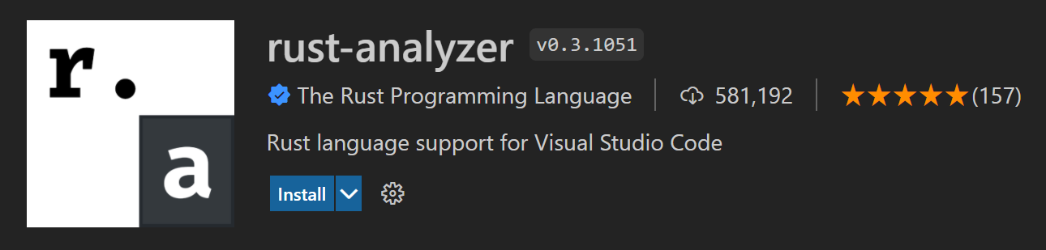

* 1. **CodeLLDB**

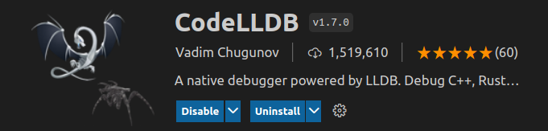

* 1. **Better TOML**

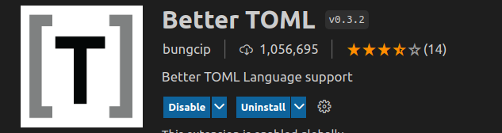

1. **Clone** [**Exercise’s**](https://github.com/andropixels/RustBootcamp.git) **repo**
2. **Sign up as a student on** [**replit**](https://replit.com/)
3. **Join** [**team**](https://replit.com/teams/join/xwgwggnsgkoksdvdjfbwydpzeycycitg-Narra8ive) **on replit**